

**Semester VI (CS, SE) Section (A) (Spring 2022) Course Instructor(s): Riaz Ali Soomro**

**CSC-325: Web Engineering - Lab**

Lab 06: JavaScript Document Object Model (DOM)

# Objective(s):

1. Learn Basics of Document Object Model

**Lab Task(s):**

**Exercises**

TASK1

<!DOCTYPE html>

<html>

<head>

 <meta charset=utf-8 />

 <title>Return first and last name from a form </title>

<script language="javascript" type="text/javascript">

function showAlert() {

    Fname=document.getElementsByName("fname")[0].value;

    Lname=document.getElementsByName("lname")[0].value;

    alert("First Name is "+Fname+"\nLast Name is "+Lname);

}

</script>

 </head>

<body>

 <form id="form1" onsubmit="showAlert()">

 First name:

 <input type="text" id="firstname" name="fname" value="David"><br>

 Last name:

 <input type="text" id="lastname" name="lname" value="Beckham"><br>

 <input type="button" value="Submit" onClick="showAlert()">

 </form>

</body>

</html>

Ouput

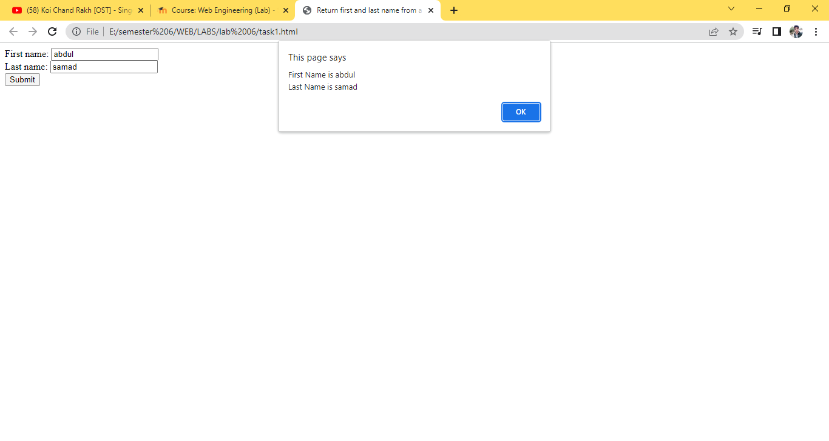

Task 2

<!DOCTYPE html>

<html>

<head>

 <meta charset=utf-8 />

 <title>JS DOM</title>

 <script language="javascript" type="text/javascript">

    function set_background() {

        bgc=document.querySelectorAll("p");

        for(i=0;i<bgc.length;i++){

            bgc[i].style.backgroundColor="red";

        }

    //     document.getElementsByTagName("p")[0].style.backgroundColor="red";

    //     document.getElementsByTagName("p")[1].style.backgroundColor="yellow";

     }

    </script>

</head>

<body>

 <input type="button" value="Click to set paragraph background color"onclick="set_background()">

 <p id="p">w3resource JavaScript Exercises</p>

 <p id="p1">w3resource PHP Exercises</p>

</body>

</html>

Output

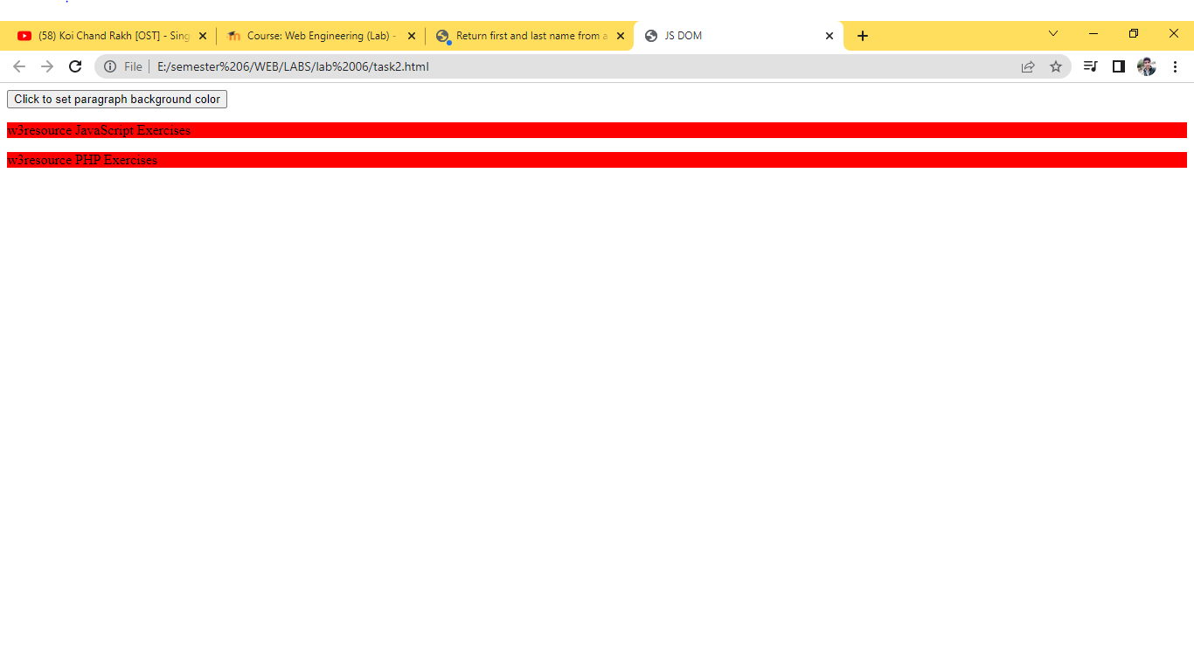

Task 3

<!DOCTYPE html>

<html>

<head>

 <meta charset=utf-8 />

<script>

 function getAttributes()

{

 b = document.getElementById("w3r").href;

c = document.getElementById("w3r").hreflang;

 d = document.getElementById("w3r").rel;

 e = document.getElementById("w3r").target;

 f = document.getElementById("w3r").type;

 document.writeln('The value of the href attribute of the link is : '+b);

 document.writeln('The value of the hreflang attribute of the link is : '+c);

 document.writeln('The value of the rel attribute of the link is : '+d);

 document.writeln('The value of the taget attribute of the link is : '+e);

 document.writeln('The value of the type attribute of the link is : '+f);

}

</Script>

</head>

<body>

 <p><a id="w3r" type="text/html" hreflang="en-us" rel="nofollow" target="_self"

 href="http://www.w3resource.com/">w3resource</a></p>

 <button onclick="getAttributes()">Click here to get attributes value</button>

</body>

</html>

Output

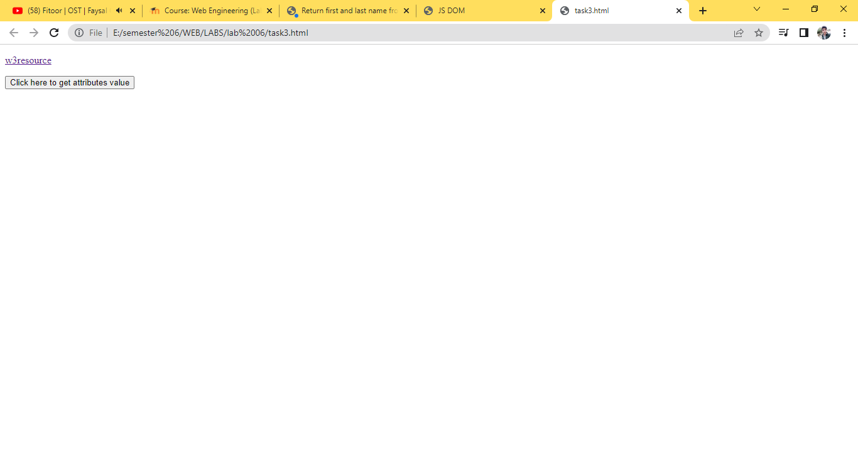

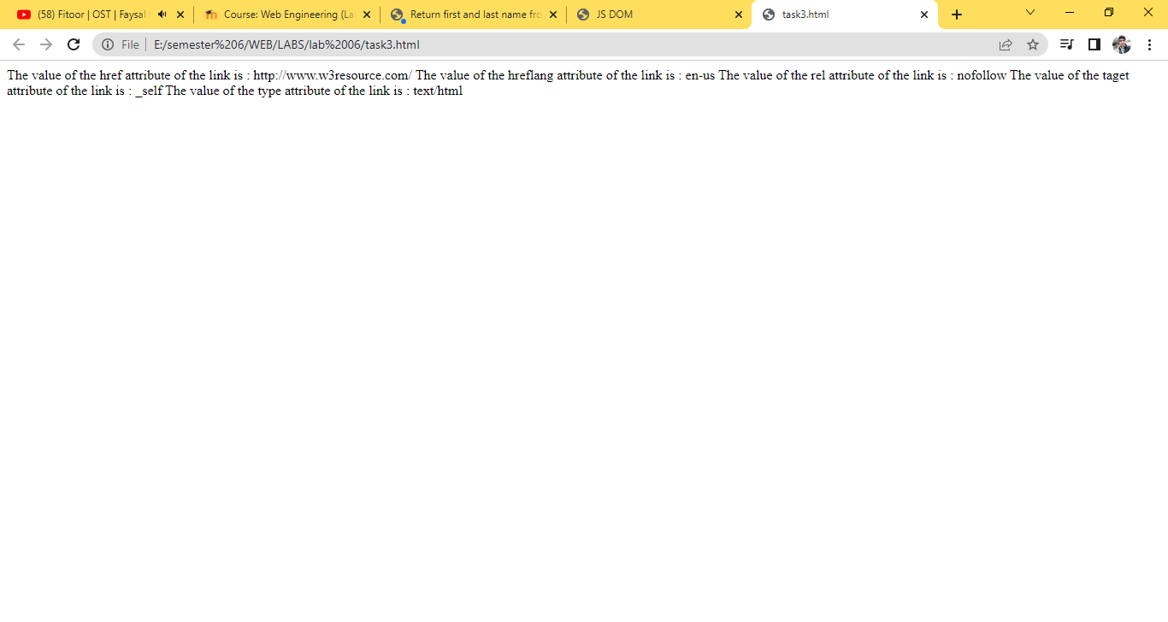

Task 4

<!DOCTYPE html>

<html><br>

<head>

 <meta charset=utf-8 />

 <title>JS DOM paragraph style</title>

 <script>

function js_style()

{

 text.style.fontSize = "15px";

 text.style.fontFamily = "serif";

 text.style.color = "red";

}

 </script>

</head>

<body>

 <p id='text'>JavaScript Exercises - w3resource</p>

 <div>

 <button id="jsstyle" onclick="js_style()">Style</button>

 </div>

</body>

</html>

Output

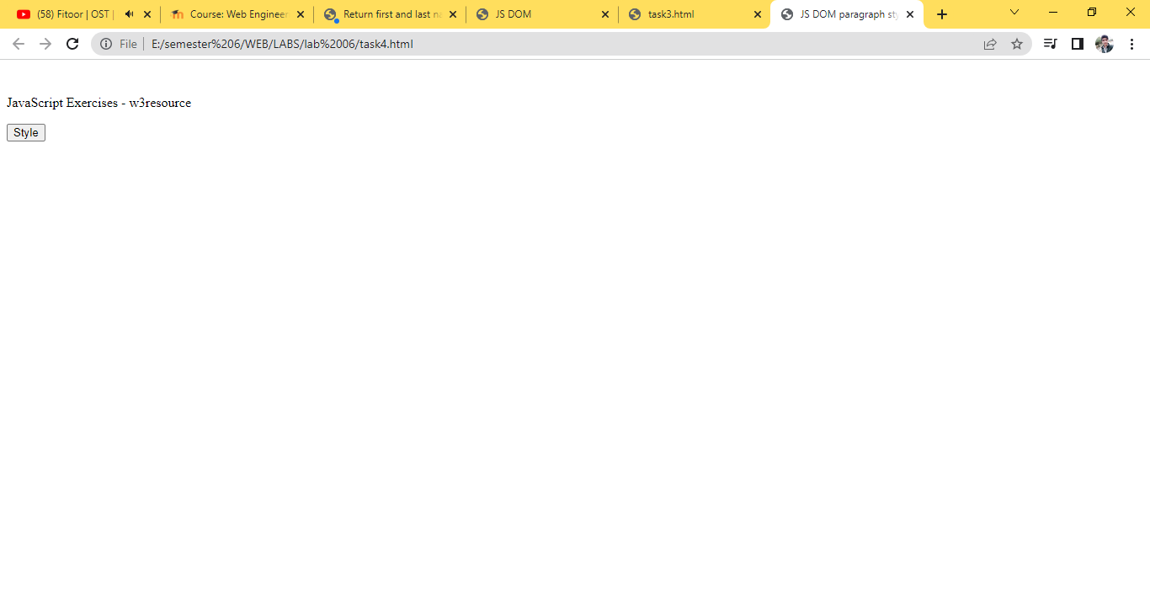

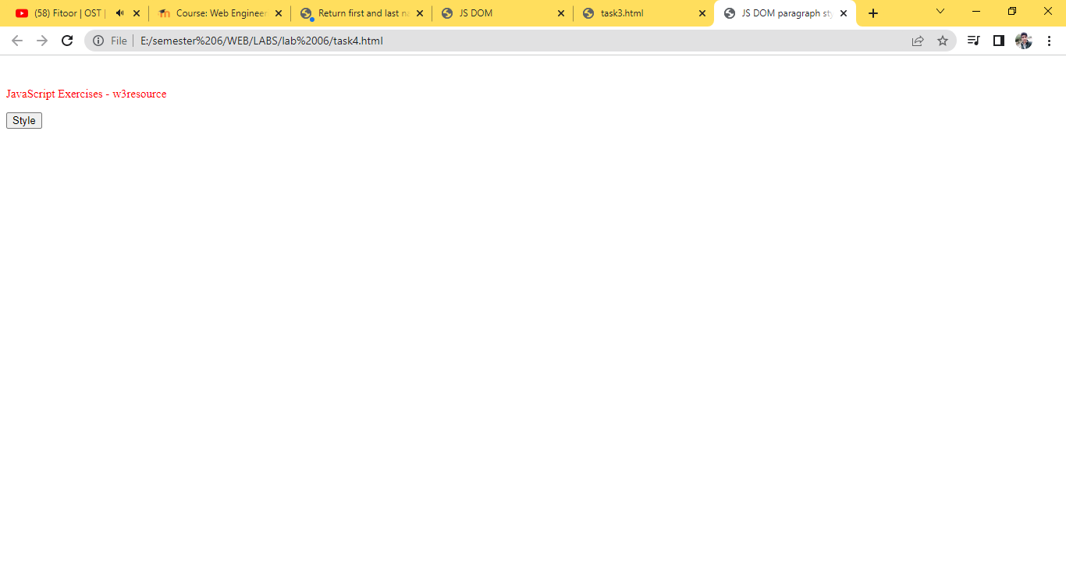

Task 5

<!DOCTYPE html>

<html>

<head><br>

 <meta charset=utf-8 />

 <title>Insert row in a table - w3resource</title>

 <script>

 function insert_Row()

{

    count=3;

x=document.getElementById('sampleTable').insertRow(0);

y = x.insertCell(0);

z = x.insertCell(1);

y.innerHTML="Inserted Cell"+count;

z.innerHTML="Inserted Cell"+count;

count+=1;

}

 </script>

</head>

<body>

 <table id="sampleTable">

 <tr>

 <td>Row1 cell1</td>

 <td>Row1 cell2</td>

 </tr>

 <tr>

 <td>Row2 cell1</td>

 <td>Row2 cell2</td>

 </tr>

 </table><br>

 <input type="button" onclick="insert_Row()" value="Insert row">

</body>

</html>

Output

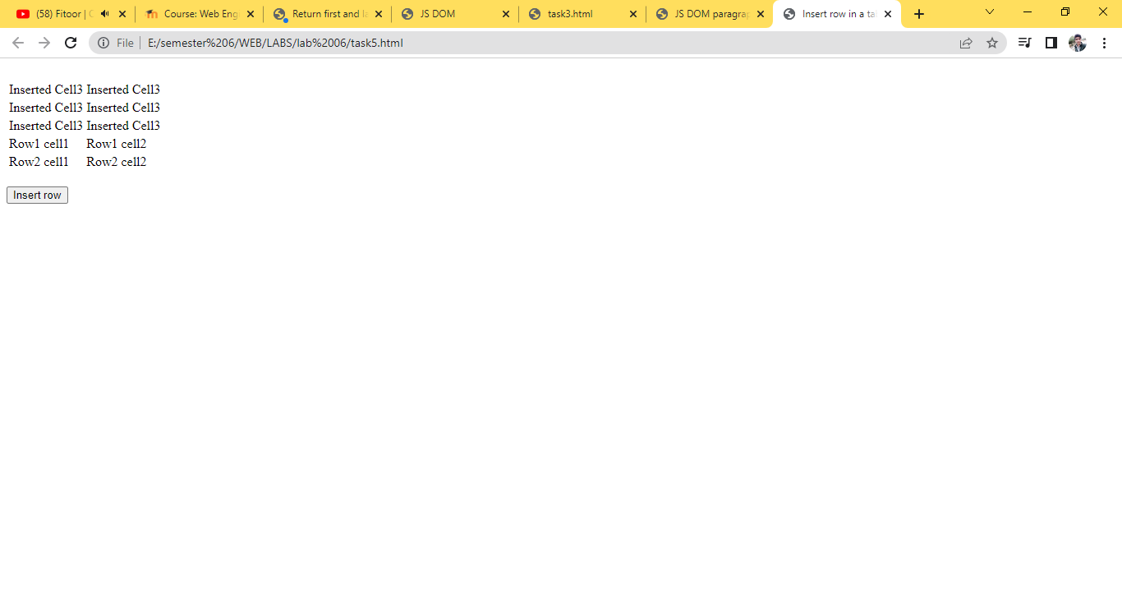

Task 6

<!DOCTYPE html>

<html lang="en">

<head>

 <meta charset="UTF-8">

 <title>Document</title>

 <script>

    document.getElementsById("container");

    document.querySelector("#container");

    document.getElementsByClassName("second")

    document.querySelector("ol .third");

    b = document.querySelector("#container");

    b.innerText = "Hello";

    footer = document.querySelector(".footer");

    footer.classList.add("main");

    footerRrmove = document.querySelector(".footer");

    footerRrmove.classList.remove("main");

    newList = document.createElement("li");

    newList.innerText = "four";

    list = document.querySelector("ul");

    list.appendChild(newLi);

    var liInsideOl = document.querySelectorAll("ol li");

    for(var i = 0; i < liInsideOl.length; i++){

    liInsideOl[i].style.backgroundColor = "green";

    }

    var footer = document.querySelector(".footer");

    footer.remove();

</script>

</head>

<body>

 <div class="header">

 </div>

 <section id="container">

 <ul>

 <li class="first">one</li>

 <li class="second">two</li>

 <li class="third">three</li>

 </ul>

 <ol>

 <li class="first">one</li>

 <li class="second">two</li>

 <li class="third">three</li>

 </ol>

 </section>

 <div class="footer">

 </div>

</body>

Output

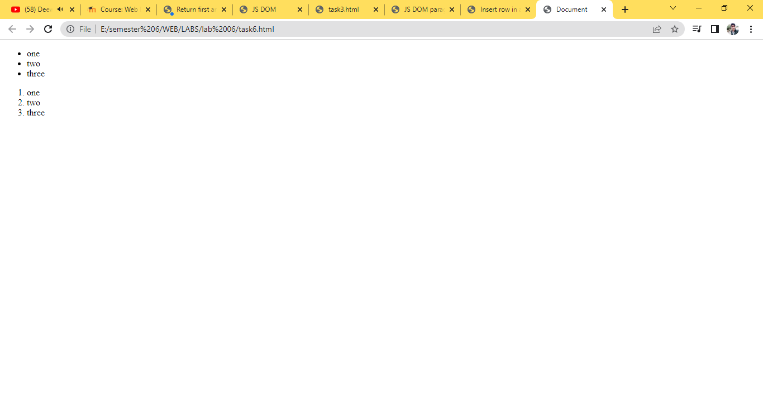

Task 7

<!DOCTYPE html>

<html lang="en">

<head>

 <meta charset="UTF-8">

 <title>DOM Exercise</title>

 <style>

 div {

 width: 50px;

 height: 50px;

 display: inline-block;

 }

 .brown{

 background-color: brown;

 }

 .green{

 background-color: green;

 }

 .blue{

 background-color: blue;

 }

 .purple{

 background-color: purple;

 }

 .yellow{

 background-color: yellow;

 }

 .car1 {

 background-color: #8C9C12;

 }

 .car2 {

 background-color: #1DA788;

 }

 .car1, .car2 {

 margin-left: 0;

 }

 </style>

</head>

<body>

 <h1 id="change_heading">Change Me!</h1>

 SELECTED COLOR <span class="selected">None!</span>

 <section>

 <div class="brown"></div>

 <div class="green"></div>

 <div class="blue"></div>

 <div class="yellow"></div>

 </section>

 <h2>Race!</h2>

 <button>Start the race!</button>

 <br>

 <div class="car1"></div>

 <br>

 <div class="car2"></div>

 <script src="script.js"></script>

</body>

</html>

Output

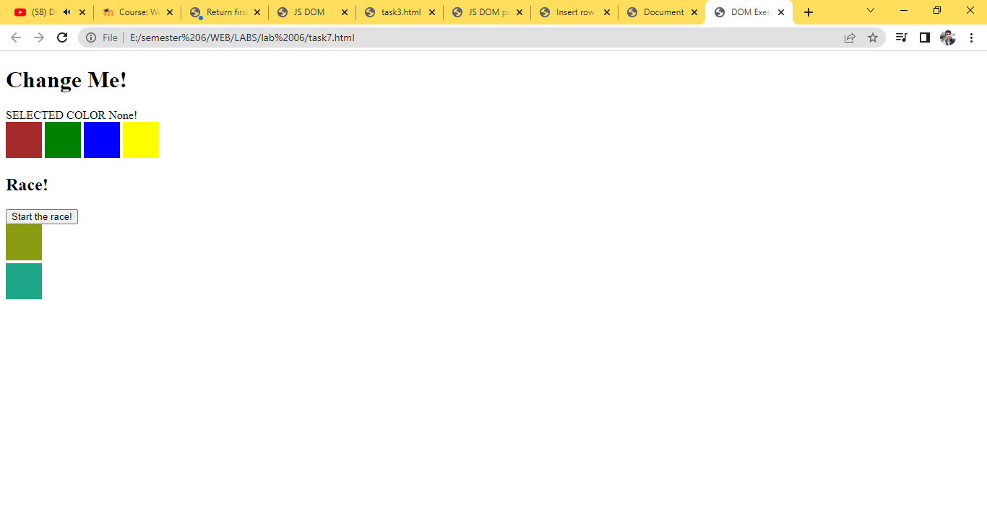

Task 8

<!DOCTYPE html>

<html>

<head>

<title>task8 </title>

<meta charset="windows-1252">

<meta name="viewport" content="width=device-width, initial-scale=1.0">

<script>

function addRow()

{

var name = document.getElementById('name').value;

var stdid = document.getElementById('id').value;

var batch = document.getElementById('batch').value;

var gpa = document.getElementById('gpa').value;

var table = document.getElementsByTagName('table')[0];

var newRow = table.insertRow(table.rows.length/2+1);

var cel1 = newRow.insertCell(0);

var cel2 = newRow.insertCell(1);

var cel3 = newRow.insertCell(2);

var cel4 = newRow.insertCell(3);

cel1.innerHTML = name;

cel2.innerHTML = stdid;

cel3.innerHTML = batch;

cel4.innerHTML = gpa;

}

</script>

</head>

<body>

Name: <input type="text" name="name" id="name" /><br/><br/>

Student ID:<input type="text" name="id" id="id" /><br/><br/>

Batch: <input type="text" name="batch" id="batch" /><br/><br/>

GPA:<input type="text" name="gpa" id="gpa" /><br/><br/>

<button onclick="addRow();">Add to Table</button><br/><br/>

<table border="1">

<tr>

<th id="stdn">Name</th>

<th id="stdID">Student ID </th>

<th id="stdbatch">Batch</th>

<th id="stdgpa">GPA</th>

</tr>

</table>

</body>

</html>

Output

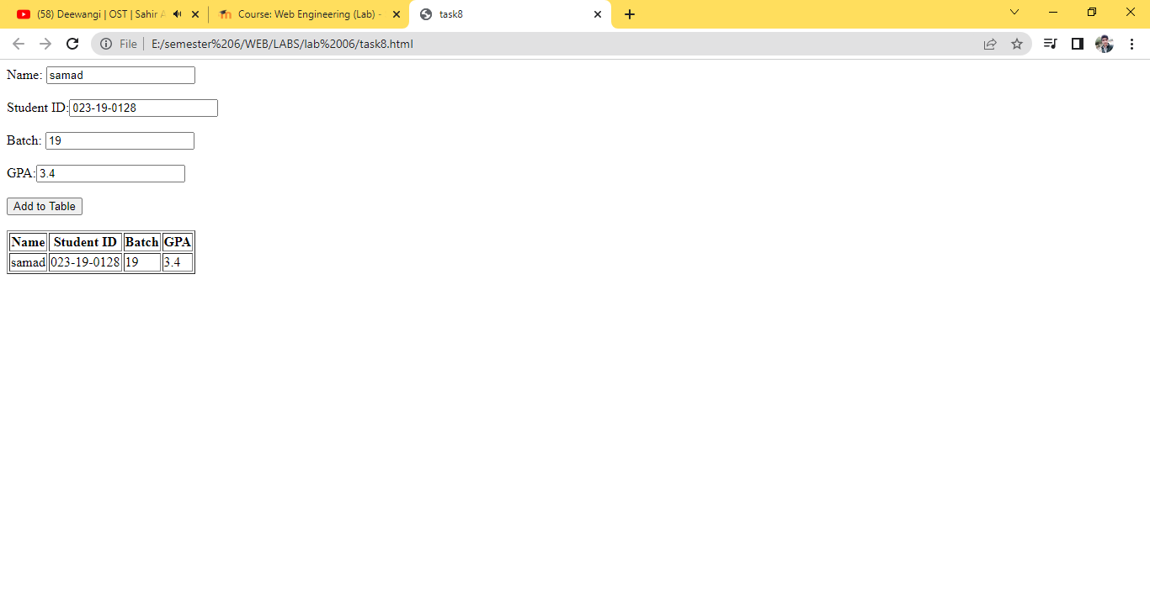

Task 9

<!DOCTYPE html>

<html>

<head>

<title></title>

<meta charset="windows-1252">

<meta name="viewport" content="width=device-width, initial-scale=1.0">

<script>

function addRow()

{

    var name = document.getElementById('name').value;

    var stdid = document.getElementById('id').value;

    var batch = document.getElementById('batch').value;

    var gpa = document.getElementById('gpa').value;

    var table = document.getElementsByTagName('table')[0];

    var newRow = table.insertRow(table.rows.length/2+1);

    var cel1 = newRow.insertCell(0);

    var cel2 = newRow.insertCell(1);

    var cel3 = newRow.insertCell(2);

    var cel4 = newRow.insertCell(3);

    var cel5 = newRow.insertCell(4);

    cel1.innerHTML = name;

    cel2.innerHTML = stdid;

    cel3.innerHTML = batch;

    cel4.innerHTML = gpa;

    cel5.innerHTML='<button onclick="deleteRow()">Delete</button>';

    function deleteRow(){

var index;

for(var i = 1; i < table.rows.length; i++)

{

        table.rows[i].cells[3].onclick = function()

        {

        index = this.parentElement.rowIndex;

        table.deleteRow(index);

};

}

    }}

</script>

</head>

<body>

Name: <input type="text" name="name" id="name" /><br/><br/>

Student ID:<input type="text" name="id" id="id" /><br/><br/>

Batch: <input type="text" name="batch" id="batch" /><br/><br/>

GPA:<input type="text" name="gpa" id="gpa" /><br/><br/>

<button onclick="addRow();">Add to Table</button><br/><br/>

<table border="1">

<tr>

<th id="stdn">Name</th>

<th id="stdID">Student ID </th>

<th id="stdbatch">Batch</th>

<th id="stdgpa">GPA</th>

<th id="btndelete">Delete</th>

</tr>

</table>

</body>

</html>

output

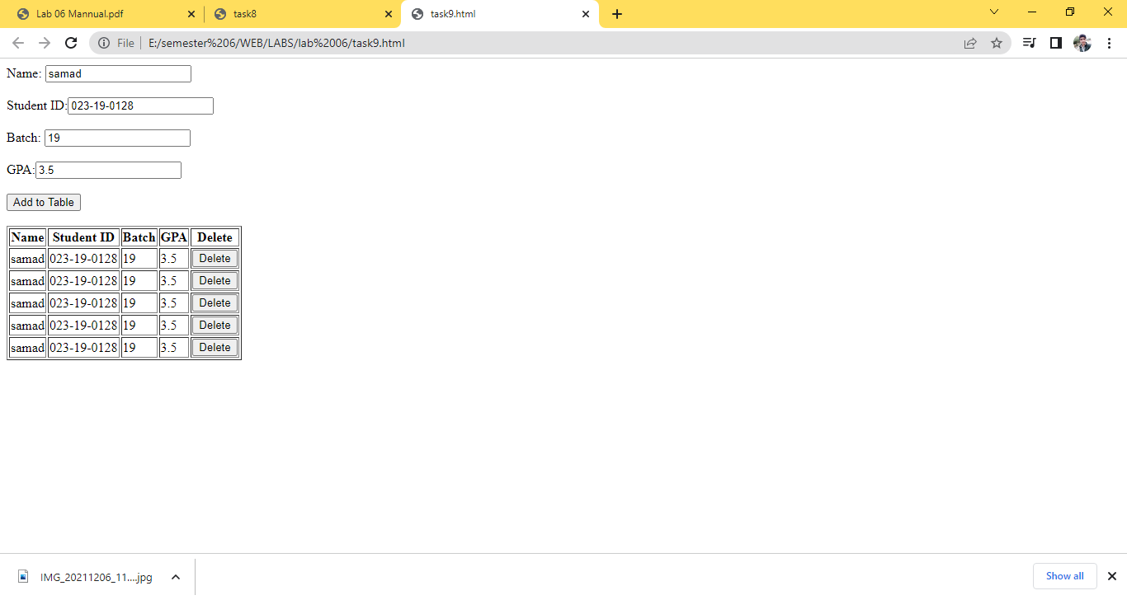

Task10

<!DOCTYPE html>

<html lang="en">

<head>

    <meta charset="UTF-8">

    <meta http-equiv="X-UA-Compatible" content="IE=edge">

    <meta name="viewport" content="width=device-width, initial-scale=1.0">

    <title>Document</title>

    </head>

<body>

    <br><br>

    <label for="">Enter any number: </label>

    <input type="text" name="" id="textField"><br>

    <br><br>

    <button>Generate Checkboxes</button>

    <button>See Selected CheckBoxes</button>

    <div id = 'checkBoxes'></div>

    <br><br>

    <p style="font-weight: bold;">The Selected checkBoxes are...</p>

    <div id="displaySelectedCheckBoxes"></div>

    </body>

    <script>

        let gc = document.getElementsByTagName('button')[0];

        let ssc = document.getElementsByTagName('button')[1];

        var count = 0;

        gc.addEventListener('click',()=>{

        let checkBoxes = document.getElementById('checkBoxes');

        checkBoxes.innerHTML="";

        count = 0;

        count = Number(document.getElementById('textField').value)

        for(let i =0;i<count;i++)

        {

        let temp = document.createElement('input')

        temp.type='checkbox'

        temp.setAttribute('id',(i+1))

        checkBoxes.appendChild(temp);

        checkBoxes.appendChild(document.createTextNode('CheckBox '+(i+1)))

        checkBoxes.appendChild(document.createElement('br'))

        }

        })

        ssc.addEventListener('click',()=>{

        let display = document.getElementById('displaySelectedCheckBoxes');

        display.innerHTML="";

        for(let i =0;i<count;i++){

        let temp = document.getElementById((i+1))

        if(temp.checked)

        {

        display.appendChild(document.createTextNode('CheckBox '+

        temp.getAttribute('id')));

        display.appendChild(document.createElement('br'));

        }

        }

        })

</script>

</html>

Output

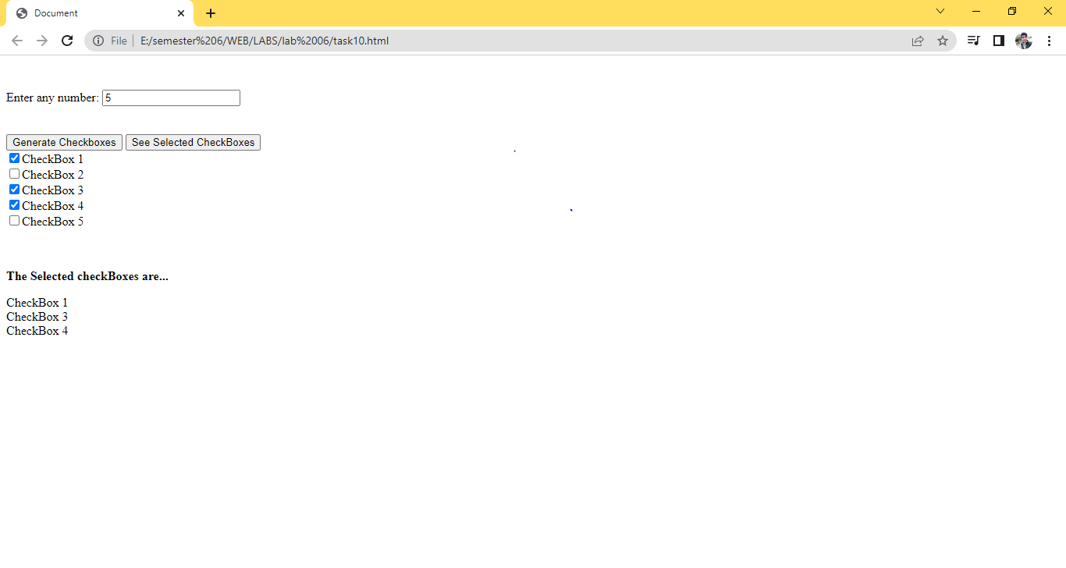

Task11

<!DOCTYPE html>

<html lang="en">

<head>

        <meta charset="UTF-8">

        <meta http-equiv="X-UA-Compatible" content="IE=edge">

        <meta name="viewport" content="width=device-width, initial-scale=1.0">

    <title>Document</title>

    </head>

<body>

    <br> <br>

    <label for="">Enter any number:</label>

    <input type="text" name="" id="textField"><br><br>

    <button>Generate Checkboxes</button><br><br>

    <input type="checkbox" id="selectDeselect">Select/Deselect All

    <div id = 'checkBoxes'></div>

    </body>

    <script>

    let gc = document.getElementsByTagName('button')[0];

    let selectOrDeselect = document.getElementById('selectDeselect');

    var count = 0;

    gc.addEventListener('click',()=>{

    let checkBoxes = document.getElementById('checkBoxes');

    checkBoxes.innerHTML="";

    count = 0;

    count = Number(document.getElementById('textField').value)

    for(let i =0;i<count;i++)

    {

    let temp = document.createElement('input')

    temp.type='checkbox'

    temp.setAttribute('id',(i+1))

    checkBoxes.appendChild(temp);

    checkBoxes.appendChild(document.createTextNode('CheckBox '+(i+1)))

    checkBoxes.appendChild(document.createElement('br'))

    }

    })

    selectOrDeselect.addEventListener('click',()=>{

    if(selectOrDeselect.checked){

         for(let i =0;i<count;i++){

        document.getElementById((i+1)).checked=true;}

    }

    else{

        for(let i =0;i<count;i++){

            document.getElementById((i+1)).checked=false;

    }

    }

    })

    </script>

</html>

Output

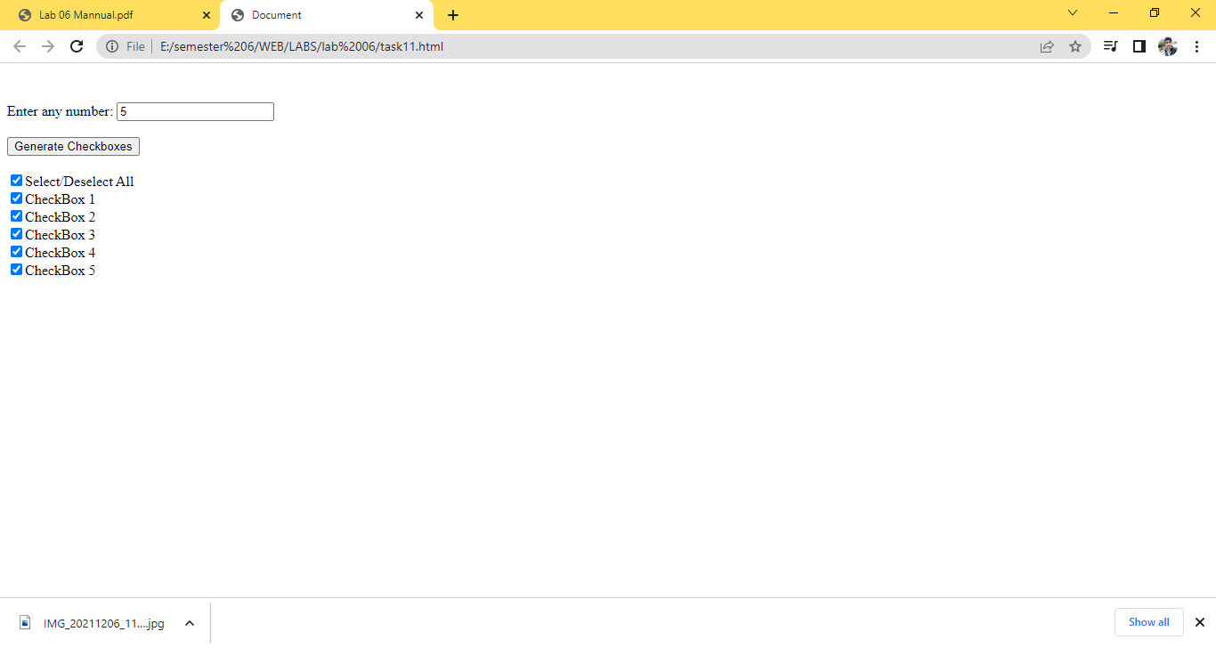

Task 12

<!DOCTYPE html>

<head>

    <meta name="viewport" content=

        "width=device-width, initial-scale=1.0">

    <style>

        h5 {

            color: rgb(14, 13, 13);

            font-size: 45px;

        }

        #b1, #b2, #b3, #b4, #b5,

        #b6, #b7, #b8, #b9 {

            width: 80px;

            height: 52px;

            margin: auto;

            border: 1px solid gray;

            border-radius: 6px;

            font-size: 30px;

            text-align: center;

        }

        #but {

            box-sizing: border-box;

            width: 95px;

            height: 40px;

            border: 1px solid dodgerblue;

            margin: auto;

            border-radius: 4px;

            font-family: Verdana,

                Geneva, Tahoma, sans-serif;

            background-color: dodgerblue;

            color: white;

            font-size: 20px;

            cursor: pointer;

        }

        #print {

            font-family: Verdana,

                Geneva, Tahoma, sans-serif;

            color: dodgerblue;

            font-size: 20px;

        }

        #main {

            text-align: center;

        }

        #ins {

            font-family: Verdana,

                Geneva, Tahoma, sans-serif;

            color: dodgerblue;

            font-size: 17px;

        }

    </style>

</head>

<body>

    <div id="main">

        <h5>TIC TAC TOE</h5>

        <br><br>

        <input type="text" id="b1" onclick=

            "myfunc_3(); myfunc();" readonly>

        <input type="text" id="b2" onclick=

            "myfunc_4(); myfunc();" readonly>

        <input type="text" id="b3" onclick=

            "myfunc_5(); myfunc();" readonly>

        <br><br>

        <input type="text" id="b4" onclick=

            "myfunc_6(); myfunc();" readonly>

        <input type="text" id="b5" onclick=

            "myfunc_7(); myfunc();" readonly>

        <input type="text" id="b6" onclick=

            "myfunc_8(); myfunc();" readonly>

        <br><br>

        <input type="text" id="b7" onclick=

            "myfunc_9(); myfunc();" readonly>

        <input type="text" id="b8" onclick=

            "myfunc_10();myfunc();" readonly>

        <input type="text" id="b9" onclick=

            "myfunc_11();myfunc();" readonly>

        <br><br><br>

        <button id="but" onclick="myfunc_2()">

            RESET

        </button>

        <br><br>

        <p id="print"></p>

    </div>

</body>

<script>

function myfunc() {

    var b1, b2, b3, b4, b5, b6, b7, b8, b9;

    b1 = document.getElementById("b1").value;

    b2 = document.getElementById("b2").value;

    b3 = document.getElementById("b3").value;

    b4 = document.getElementById("b4").value;

    b5 = document.getElementById("b5").value;

    b6 = document.getElementById("b6").value;

    b7 = document.getElementById("b7").value;

    b8 = document.getElementById("b8").value;

    b9 = document.getElementById("b9").value;

    if ((b1 == 'x' || b1 == 'X') && (b2 == 'x' ||

        b2 == 'X') && (b3 == 'x' || b3 == 'X')) {

        document.getElementById('print')

            .innerHTML = "Player X won";

        document.getElementById("b4").disabled = true;

        document.getElementById("b5").disabled = true;

        document.getElementById("b6").disabled = true;

        document.getElementById("b7").disabled = true;

        document.getElementById("b8").disabled = true;

        document.getElementById("b9").disabled = true;

        window.alert('Player X won');

    }

    else if ((b1 == 'x' || b1 == 'X') && (b4 == 'x' ||

        b4 == 'X') && (b7 == 'x' || b7 == 'X')) {

        document.getElementById('print')

            .innerHTML = "Player X won";

        document.getElementById("b2").disabled = true;

        document.getElementById("b3").disabled = true;

        document.getElementById("b5").disabled = true;

        document.getElementById("b6").disabled = true;

        document.getElementById("b8").disabled = true;

        document.getElementById("b9").disabled = true;

        window.alert('Player X won');

    }

    else if ((b7 == 'x' || b7 == 'X') && (b8 == 'x' ||

        b8 == 'X') && (b9 == 'x' || b9 == 'X')) {

        document.getElementById('print')

            .innerHTML = "Player X won";

        document.getElementById("b1").disabled = true;

        document.getElementById("b2").disabled = true;

        document.getElementById("b3").disabled = true;

        document.getElementById("b4").disabled = true;

        document.getElementById("b5").disabled = true;

        document.getElementById("b6").disabled = true;

        window.alert('Player X won');

    }

    else if ((b3 == 'x' || b3 == 'X') && (b6 == 'x' ||

        b6 == 'X') && (b9 == 'x' || b9 == 'X')) {

        document.getElementById('print')

            .innerHTML = "Player X won";

        document.getElementById("b1").disabled = true;

        document.getElementById("b2").disabled = true;

        document.getElementById("b4").disabled = true;

        document.getElementById("b5").disabled = true;

        document.getElementById("b7").disabled = true;

        document.getElementById("b8").disabled = true;

        window.alert('Player X won');

    }

    else if ((b1 == 'x' || b1 == 'X') && (b5 == 'x' ||

        b5 == 'X') && (b9 == 'x' || b9 == 'X')) {

        document.getElementById('print')

            .innerHTML = "Player X won";

        document.getElementById("b2").disabled = true;

        document.getElementById("b3").disabled = true;

        document.getElementById("b4").disabled = true;

        document.getElementById("b6").disabled = true;

        document.getElementById("b7").disabled = true;

        document.getElementById("b8").disabled = true;

        window.alert('Player X won');

    }

    else if ((b3 == 'x' || b3 == 'X') && (b5 == 'x' ||

        b5 == 'X') && (b7 == 'x' || b7 == 'X')) {

        document.getElementById('print')

            .innerHTML = "Player X won";

        document.getElementById("b1").disabled = true;

        document.getElementById("b2").disabled = true;

        document.getElementById("b4").disabled = true;

        document.getElementById("b6").disabled = true;

        document.getElementById("b8").disabled = true;

        document.getElementById("b9").disabled = true;

        window.alert('Player X won');

    }

    else if ((b2 == 'x' || b2 == 'X') && (b5 == 'x' ||

        b5 == 'X') && (b8 == 'x' || b8 == 'X')) {

        document.getElementById('print')

            .innerHTML = "Player X won";

        document.getElementById("b1").disabled = true;

        document.getElementById("b3").disabled = true;

        document.getElementById("b4").disabled = true;

        document.getElementById("b6").disabled = true;

        document.getElementById("b7").disabled = true;

        document.getElementById("b9").disabled = true;

        window.alert('Player X won');

    }

    else if ((b4 == 'x' || b4 == 'X') && (b5 == 'x' ||

        b5 == 'X') && (b6 == 'x' || b6 == 'X')) {

        document.getElementById('print')

            .innerHTML = "Player X won";

        document.getElementById("b1").disabled = true;

        document.getElementById("b2").disabled = true;

        document.getElementById("b3").disabled = true;

        document.getElementById("b7").disabled = true;

        document.getElementById("b8").disabled = true;

        document.getElementById("b9").disabled = true;

        window.alert('Player X won');

    }

    else if ((b1 == '0' || b1 == '0') && (b2 == '0' ||

        b2 == '0') && (b3 == '0' || b3 == '0')) {

        document.getElementById('print')

            .innerHTML = "Player 0 won";

        document.getElementById("b4").disabled = true;

        document.getElementById("b5").disabled = true;

        document.getElementById("b6").disabled = true;

        document.getElementById("b7").disabled = true;

        document.getElementById("b8").disabled = true;

        document.getElementById("b9").disabled = true;

        window.alert('Player 0 won');

    }

    else if ((b1 == '0' || b1 == '0') && (b4 == '0' ||

        b4 == '0') && (b7 == '0' || b7 == '0')) {

        document.getElementById('print')

            .innerHTML = "Player 0 won";

        document.getElementById("b2").disabled = true;

        document.getElementById("b3").disabled = true;

        document.getElementById("b5").disabled = true;

        document.getElementById("b6").disabled = true;

        document.getElementById("b8").disabled = true;

        document.getElementById("b9").disabled = true;

        window.alert('Player 0 won');

    }

    else if ((b7 == '0' || b7 == '0') && (b8 == '0' ||

        b8 == '0') && (b9 == '0' || b9 == '0')) {

        document.getElementById('print')

            .innerHTML = "Player 0 won";

        document.getElementById("b1").disabled = true;

        document.getElementById("b2").disabled = true;

        document.getElementById("b3").disabled = true;

        document.getElementById("b4").disabled = true;

        document.getElementById("b5").disabled = true;

        document.getElementById("b6").disabled = true;

        window.alert('Player 0 won');

    }

    else if ((b3 == '0' || b3 == '0') && (b6 == '0' ||

        b6 == '0') && (b9 == '0' || b9 == '0')) {

        document.getElementById('print')

            .innerHTML = "Player 0 won";

        document.getElementById("b1").disabled = true;

        document.getElementById("b2").disabled = true;

        document.getElementById("b4").disabled = true;

        document.getElementById("b5").disabled = true;

        document.getElementById("b7").disabled = true;

        document.getElementById("b8").disabled = true;

        window.alert('Player 0 won');

    }

    else if ((b1 == '0' || b1 == '0') && (b5 == '0' ||

        b5 == '0') && (b9 == '0' || b9 == '0')) {

        document.getElementById('print')

            .innerHTML = "Player 0 won";

        document.getElementById("b2").disabled = true;

        document.getElementById("b3").disabled = true;

        document.getElementById("b4").disabled = true;

        document.getElementById("b6").disabled = true;

        document.getElementById("b7").disabled = true;

        document.getElementById("b8").disabled = true;

        window.alert('Player 0 won');

    }

    else if ((b3 == '0' || b3 == '0') && (b5 == '0' ||

        b5 == '0') && (b7 == '0' || b7 == '0')) {

        document.getElementById('print')

            .innerHTML = "Player 0 won";

        document.getElementById("b1").disabled = true;

        document.getElementById("b2").disabled = true;

        document.getElementById("b4").disabled = true;

        document.getElementById("b6").disabled = true;

        document.getElementById("b8").disabled = true;

        document.getElementById("b9").disabled = true;

        window.alert('Player 0 won');

    }

    else if ((b2 == '0' || b2 == '0') && (b5 == '0' ||

        b5 == '0') && (b8 == '0' || b8 == '0')) {

        document.getElementById('print')

            .innerHTML = "Player 0 won";

        document.getElementById("b1").disabled = true;

        document.getElementById("b3").disabled = true;

        document.getElementById("b4").disabled = true;

        document.getElementById("b6").disabled = true;

        document.getElementById("b7").disabled = true;

        document.getElementById("b9").disabled = true;

        window.alert('Player 0 won');

    }

    else if ((b4 == '0' || b4 == '0') && (b5 == '0' ||

        b5 == '0') && (b6 == '0' || b6 == '0')) {

        document.getElementById('print')

            .innerHTML = "Player 0 won";

        document.getElementById("b1").disabled = true;

        document.getElementById("b2").disabled = true;

        document.getElementById("b3").disabled = true;

        document.getElementById("b7").disabled = true;

        document.getElementById("b8").disabled = true;

        document.getElementById("b9").disabled = true;

        window.alert('Player 0 won');

    }

    else if ((b1 == 'X' || b1 == '0') && (b2 == 'X'

        || b2 == '0') && (b3 == 'X' || b3 == '0') &&

        (b4 == 'X' || b4 == '0') && (b5 == 'X' ||

        b5 == '0') && (b6 == 'X' || b6 == '0') &&

        (b7 == 'X' || b7 == '0') && (b8 == 'X' ||

        b8 == '0') && (b9 == 'X' || b9 == '0')) {

            document.getElementById('print')

                .innerHTML = "Match Tie";

            window.alert('Match Tie');

    }

    else {

        if (flag == 1) {

            document.getElementById('print')

                .innerHTML = "Player X Turn";

        }

        else {

            document.getElementById('print')

                .innerHTML = "Player 0 Turn";

        }

    }

}

function myfunc_2() {

    location.reload();

    document.getElementById('b1').value = '';

    document.getElementById("b2").value = '';

    document.getElementById("b3").value = '';

    document.getElementById("b4").value = '';

    document.getElementById("b5").value = '';

    document.getElementById("b6").value = '';

    document.getElementById("b7").value = '';

    document.getElementById("b8").value = '';

    document.getElementById("b9").value = '';

}

flag = 1;

function myfunc_3() {

    if (flag == 1) {

        document.getElementById("b1").value = "X";

        document.getElementById("b1").disabled = true;

        flag = 0;

    }

    else {

        document.getElementById("b1").value = "0";

        document.getElementById("b1").disabled = true;

        flag = 1;

    }

}

function myfunc_4() {

    if (flag == 1) {

        document.getElementById("b2").value = "X";

        document.getElementById("b2").disabled = true;

        flag = 0;

    }

    else {

        document.getElementById("b2").value = "0";

        document.getElementById("b2").disabled = true;

        flag = 1;

    }

}

function myfunc_5() {

    if (flag == 1) {

        document.getElementById("b3").value = "X";

        document.getElementById("b3").disabled = true;

        flag = 0;

    }

    else {

        document.getElementById("b3").value = "0";

        document.getElementById("b3").disabled = true;

        flag = 1;

    }

}

function myfunc_6() {

    if (flag == 1) {

        document.getElementById("b4").value = "X";

        document.getElementById("b4").disabled = true;

        flag = 0;

    }

    else {

        document.getElementById("b4").value = "0";

        document.getElementById("b4").disabled = true;

        flag = 1;

    }

}

function myfunc_7() {

    if (flag == 1) {

        document.getElementById("b5").value = "X";

        document.getElementById("b5").disabled = true;

        flag = 0;

    }

    else {

        document.getElementById("b5").value = "0";

        document.getElementById("b5").disabled = true;

        flag = 1;

    }

}

function myfunc_8() {

    if (flag == 1) {

        document.getElementById("b6").value = "X";

        document.getElementById("b6").disabled = true;

        flag = 0;

    }

    else {

        document.getElementById("b6").value = "0";

        document.getElementById("b6").disabled = true;

        flag = 1;

    }

}

function myfunc_9() {

    if (flag == 1) {

        document.getElementById("b7").value = "X";

        document.getElementById("b7").disabled = true;

        flag = 0;

    }

    else {

        document.getElementById("b7").value = "0";

        document.getElementById("b7").disabled = true;

        flag = 1;

    }

}

function myfunc_10() {

    if (flag == 1) {

        document.getElementById("b8").value = "X";

        document.getElementById("b8").disabled = true;

        flag = 0;

    }

    else {

        document.getElementById("b8").value = "0";

        document.getElementById("b8").disabled = true;

        flag = 1;

    }

}

function myfunc_11() {

    if (flag == 1) {

        document.getElementById("b9").value = "X";

        document.getElementById("b9").disabled = true;

        flag = 0;

    }

    else {

        document.getElementById("b9").value = "0";

        document.getElementById("b9").disabled = true;

        flag = 1;

    }

}

</script>

</html>

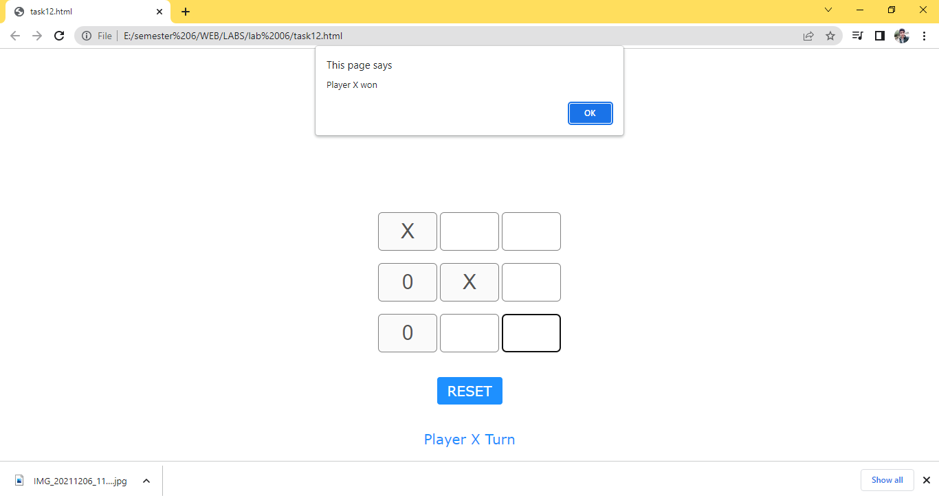

Task 13

<!DOCTYPE html>

<html>

<head>

<meta name="viewport" content="width=device-width, initial-scale=1">

<style>

body {

  margin: 0;

  min-width: 250px;

}

* {

  box-sizing: border-box;

}

ul {

  margin: 0;

  padding: 0;

}

ul li {

  cursor: pointer;

  position: relative;

  padding: 12px 8px 12px 40px;

  list-style-type: none;

  background: #eee;

  font-size: 18px;

  transition: 0.2s;

  -webkit-user-select: none;

  -moz-user-select: none;

  -ms-user-select: none;

  user-select: none;

}

ul li:nth-child(odd) {

  background: #f9f9f9;

}

ul li:hover {

  background: #ddd;

}

ul li.checked {

  background: #888;

  color: #fff;

  text-decoration: line-through;

}

ul li.checked::before {

  content: '';

  position: absolute;

  border-color: #fff;

  border-style: solid;

  border-width: 0 2px 2px 0;

  top: 10px;

  left: 16px;

  transform: rotate(45deg);

  height: 15px;

  width: 7px;

}

.close {

  position: absolute;

  right: 0;

  top: 0;

  padding: 12px 16px 12px 16px;

}

.close:hover {

  background-color: #f44336;

  color: white;

}

.header {

  background-color: #3b3535;

  padding: 30px 40px;

  color: white;

  text-align: center;

}

.header:after {

  content: "";

  display: table;

  clear: both;

}

input {

  margin: 0;

  border: none;

  border-radius: 0;

  width: 75%;

  padding: 10px;

  float: left;

  font-size: 16px;

}

.addBtn {

  padding: 10px;

  width: 25%;

  background: #d9d9d9;

  color: #555;

  float: left;

  text-align: center;

  font-size: 16px;

  cursor: pointer;

  transition: 0.3s;

  border-radius: 0;

}

.addBtn:hover {

  background-color: #bbb;

}

</style>

</head>

<body>

<div id="myDIV" class="header">

  <h2 style="margin:5px">My To Do List</h2>

  <input type="text" id="myInput">

  <span onclick="newElement()" class="addBtn">Add</span>

</div>

<ul id="myUL">

</ul>

<script>

var myNodelist = document.getElementsByTagName("LI");

var i;

for (i = 0; i < myNodelist.length; i++) {

  var span = document.createElement("SPAN");

  var txt = document.createTextNode("\u00D7");

  span.className = "close";

  span.appendChild(txt);

  myNodelist[i].appendChild(span);

}

var close = document.getElementsByClassName("close");

var i;

for (i = 0; i < close.length; i++) {

  close[i].onclick = function() {

    var div = this.parentElement;

    div.style.display = "none";

  }

}

var list = document.querySelector('ul');

list.addEventListener('click', function(ev) {

  if (ev.target.tagName === 'LI') {

    ev.target.classList.toggle('checked');

  }

}, false);

function newElement() {

  var li = document.createElement("li");

  var inputValue = document.getElementById("myInput").value;

  var t = document.createTextNode(inputValue);

  li.appendChild(t);

  if (inputValue === '') {

    alert("You must write something!");

  } else {

    document.getElementById("myUL").appendChild(li);

  }

  document.getElementById("myInput").value = "";

  var span = document.createElement("SPAN");

  var txt = document.createTextNode("\u00D7");

  span.className = "close";

  span.appendChild(txt);

  li.appendChild(span);

  for (i = 0; i < close.length; i++) {

    close[i].onclick = function() {

      var div = this.parentElement;

      div.style.display = "none";

    }

  }

}

</script>

</body>

</html>

